**Create Flow from Template**

For Create a Flow form Template you have to follow below given steps.

Step 1: go to flow.microsoft.com and click on the Import button.



Step 2: after that you have to upload the zip file which is provided into the GitHub solution.

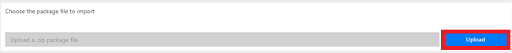

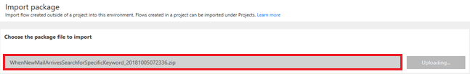

Step 3: You’ll have Configuration Screen where you have to configure the Connection to Perform Various Operations with the system like SharePoint, Twitter, Approval, Office 365 Outlook etc.

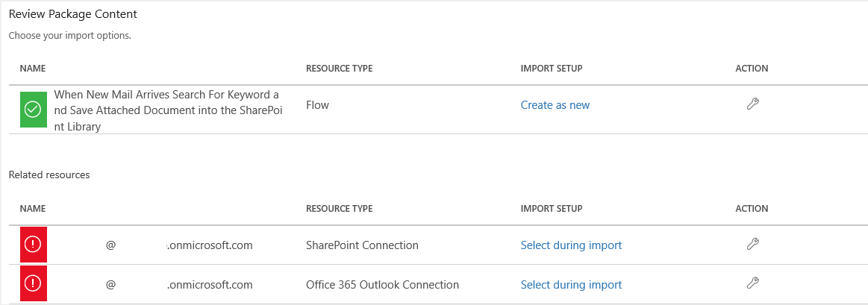

Step 4: Once you Configure all the Connections the Import button will be active just click on the Import.

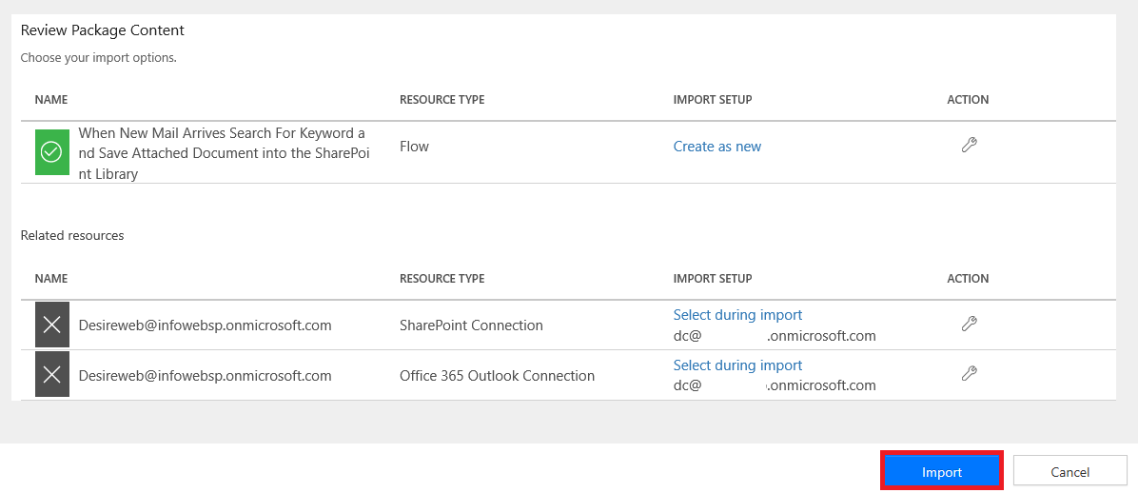

After Few seconds you have message that Flow has been created successfully.



Now you have the Ready Solution for your Automation or Integration Process.